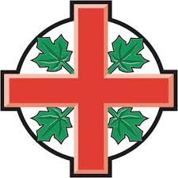

Certificate of Holy Baptism

FULL NAME

was baptised with water,
in the name of the Father and of the Son and of the Holy Spirit,
according to the rites of The Anglican Church of Canada,

by

at

on

________________________________________
Signature of Priest
May God,
who has received you by baptism,
pour upon you the riches of God’s grace,
that within the family of all Christian people
you may daily be renewed by God’s Holy Spirit
and share a place with all the saints in glory.
Amen.

Jesus said,
‘As the Father has loved me, even so I love you; remain always in my love’.

John15:9

