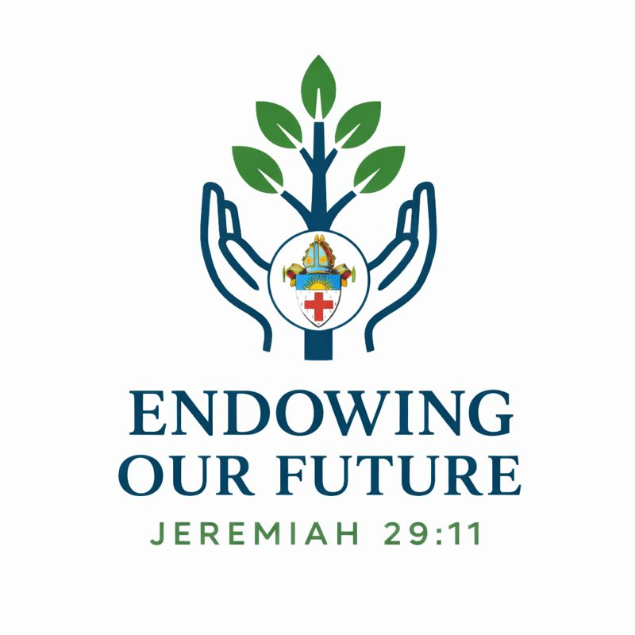
How is the Synod office committing themselves to this campaign?

First and foremost, we are listening to scripture and praying. We have set up a monthly prayer gathering so that you can join us in listening to God’s word and praying for His Spirit to guide us in this work.

Truly I tell you, if you have faith as small as a mustard seed, you can say to this mountain, ‘Move from here to there,’ and it will move. Nothing will be impossible for you.” Matthew 17: 20.

Not knowing God’s plan is part of the mystery and blessings. He is capable of creating miracles beyond all logic. We have faith that we can move this mountain with His help.

We are intentionally spending time in visioning and planning to ensure that the money we have to do our work is used in accordance with this plan. We are working to support parishes to worship, serve and grow with excellence, by fostering transparency, authenticity, and responsiveness.

Bishop Helen has committed to make a monthly donation herself beginning in 2026. Other staff are also making similar commitments.

All that we do is for your parish. We care about you and want you to thrive. This campaign is all about making sure that you can.

