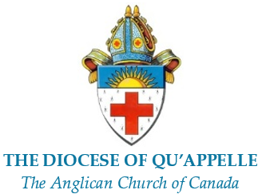

This is to Certify that

FULL (including middle) NAME

was
CONFIRMED
with the laying on of hands and prayer according to the rites of the Anglican Church of Canada by
The Rt Rev Helen Kennedy, XIII Bishop of Qu’Appelle

at…………………………….
on …………………………….

______________________________ ______________________________
Bishop Presented by

May God pour upon you the riches of God’s grace, that within the family of all Christian people
you may daily be renewed by the Holy Spirit and share a place with all the saints in glory.
Amen.



Your membership in the Church extends far beyond your local congregation. Baptism and Confirmation have initiated you into the family of the Christian Church, in particular that branch of it called “the Anglican Communion”. You belong to a world-wide fellowship.

Drawing its teaching from the Bible, the Anglican Communion holds the belief of the early Church as summarized in the Creeds. In its ministry of Bishops, Priests and Deacons and its emphasis on the Sacraments of Holy Baptism and Holy Communion, instituted by Christ, it preserves the ancient structure and practice of the Church while seeking to fulfil God’s will in each generation.

At the Lambeth Conference the Bishops representing the world-wide Anglican Communion have stated that:

All Church people should look upon their membership of Christ in the Church as the central fact in their lives.
They should regard themselves as individually sharing responsibility for the corporate life and witness of the Church in the place where they live.

They should discharge their responsibility and give a distinctive witness by:

(a) the regularity of their attendance at public worship and especially at Holy Communion;
(b) the practice of private prayer, Bible reading and self-discipline;
(c) bringing the teaching and example of Christ into their every-day lives;
(d) the boldness of their spoken witness to their faith in Christ;
(e) personal service to Church and community;
(f) the offering of money, according to their means, for the support of the work of the Church at home and overseas.

