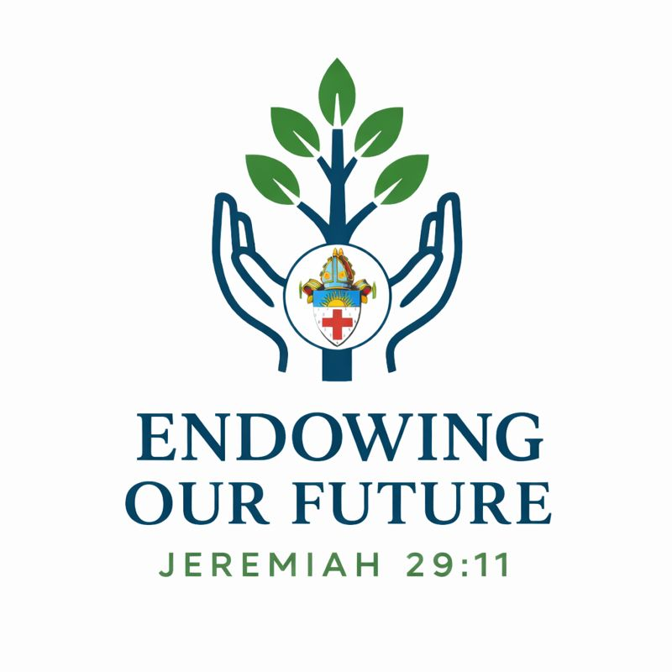
Diocesan family connection

One of our biggest challenges as a diocese is connection. We know that connection between your parish and the Synod office and your connection to other parishes is lacking.

We know it’s a challenge and we also know that we would be better equipped to worship, serve and grow if we were better connected. We believe that face-to-face connection is the most effective way to achieve this.

In 2026, we are making plans to come out to a few parishes in the diocese, bringing stories and hopes, fears, challenges from both the Synod office and other parishes. You are invited. When we take a trip to visit a parish, we’d like you to come along, bringing your perspective and story.

We are all part of this diocesan family. We know so many people don’t feel connected to this family. Our hope is that better connection will lead to better support and encouragement for all of us as we worship, serve and grow in our communities.

You can support this work to be better connected as a parish by:

- Coming on one or two parish visits and sharing what hopes, joys and challenges your parish is facing and what your parish would do with more money in its hands if your fair share was reduced. Where is God at work?
- Creating a written or video story about hopes, joys and challenges your parish is facing and what your parish would do with more money in its hands if your fair share was reduced. Where is God at work?
- Tell us what we and others in the diocese can pray for your parish

